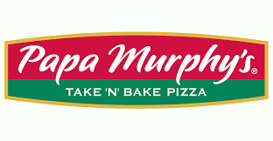
Pizza: $3.75 slice: Cheese
Pepperoni
Cowboy
Chicken Garlic
Garden Veggie

Lemon Shake Ups: Large $5.00
Small $3.00

Canned soda and bottled water $1.25

S’mores cookie bars: $2.25

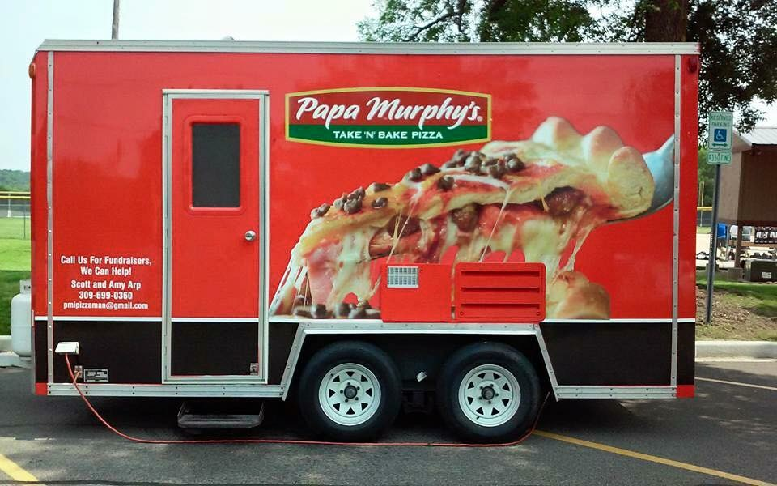3125 N. University Street
Peoria, Il. 61604
309-686-3700

